Project On Time Series
Forecasting

Sparkling Wine

Yogesh Negi

Problem Statement:

For this particular assignment, the data of different types of wine sales in the 20th century is to be analysed. Both of these data are from the same company but of different wines. As an analyst in the ABC Estate Wines, you are tasked to analyse and forecast Wine Sales in the 20th century.

Read the data as an appropriate Time Series data and plot the data.

Data Dictionary:

Column name | Details
YearMonth | Dates of sales
Sparkling | Sales of sparkling wine
Table 1: data dictionary

Data set is read using pandas library.
Rows of data set;

Top Few Rows: | Last Few Rows:
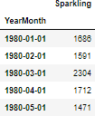 | 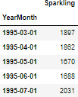
Table 2: rows of data

We can see data is from 1980 to 1995.
The number of Rows and Columns of the Dataset:
The dataset has 187 rows and 1 column.

Plot of the dataset:

Plot 1: dataset

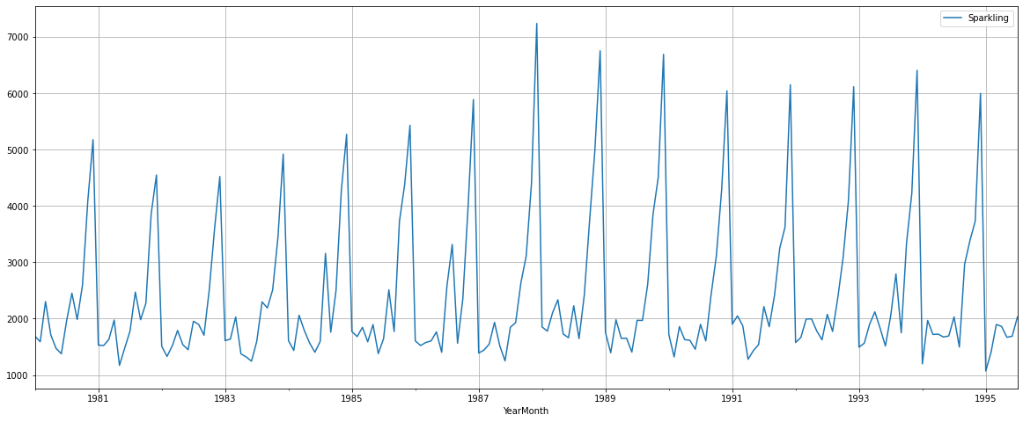

Post Ingestion of Dataset:
We have divided the dataset further by extraction month and year columns from the YearMonth column and renamed the sparkling column name to Sales for better analysis of the dataset. The new dataset has 187 rows and 3 columns.

Rows of the new data set;
Table 3 : rows of new dataset

Top Few Rows: | Last Few Rows:
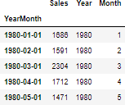 | 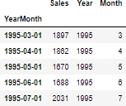

Perform appropriate Exploratory Data Analysis to understand the data and also perform decomposition.

Data Type;
Index: DateTime Sales: integer Month: integer Year: integer

Statistical summary:
Table 4: statistical summary of data

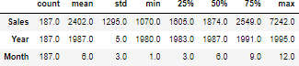

Null Value:
There are no null values present in the dataset. So we can do further analysis smoothly.

Boxplot of dataset: plot 2: box plot of data
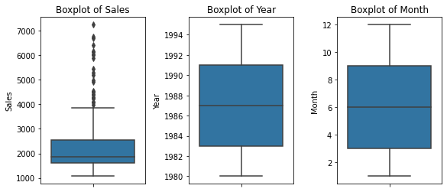

The box plot shows:
  - Sales boxplot has outliers we can treat them but we are choosing not to treat them as they do not give much eﬀect on the time series model.

Line plot of sales:
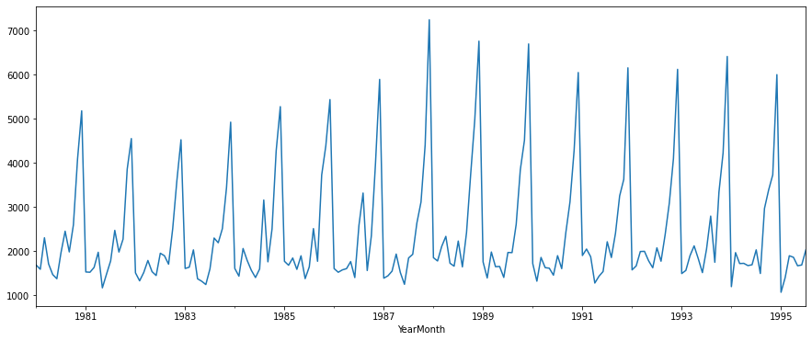
Plo 3: line plot for sales
The line plot shows the patterns of trend and seasonality and also shows that there was a peak in the year 1988.

Boxplot Yearly:
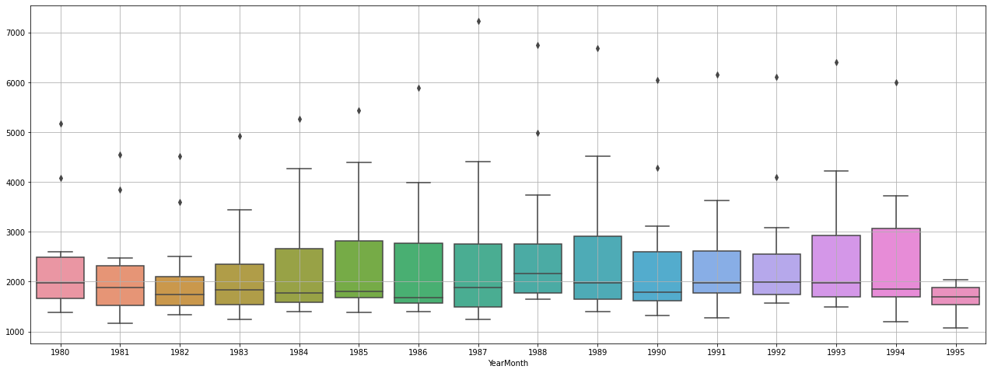
Plot 4: boxplot yearly
This yearly box plot shows there is consistency over the years and there was a peak in 1988-1989. Outliers are present in all years.

Boxplot Monthly:

Plot 5: boxplot monthly

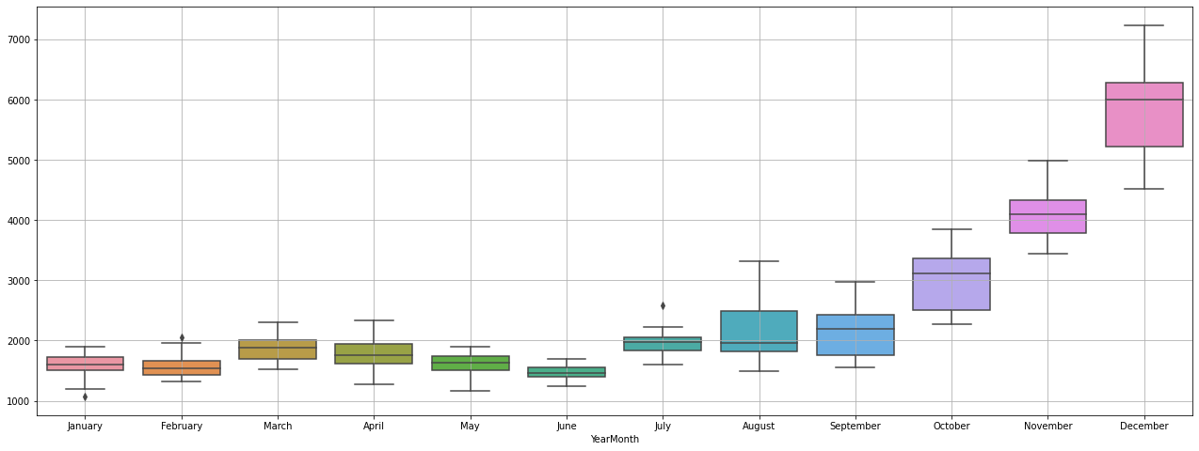

The plot shows that sales are highest in the month of December and lowest in the month of January. Sales are consistent from January to July then from august the sales start to increase. Outliers are present in January, February and July.

Boxplot Weekday wise:
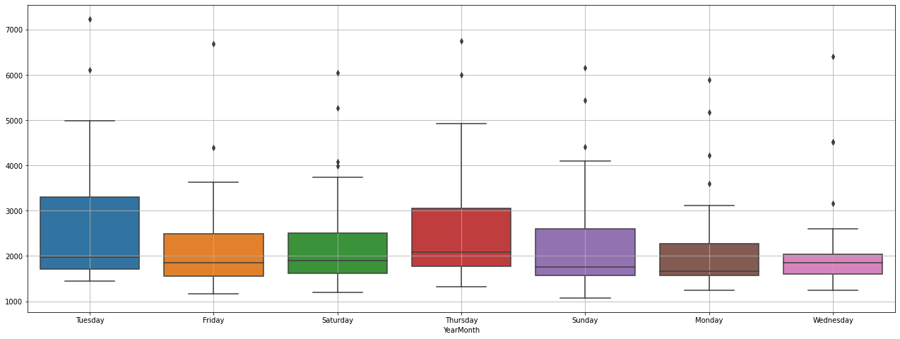
Plot 6: Boxplot weekday vise
Tuesday has more sales than other days and Wednesday has the lowest sales of the week. Outliers are present on all days which is understandable.

Graph of Monthly Sales over the years:
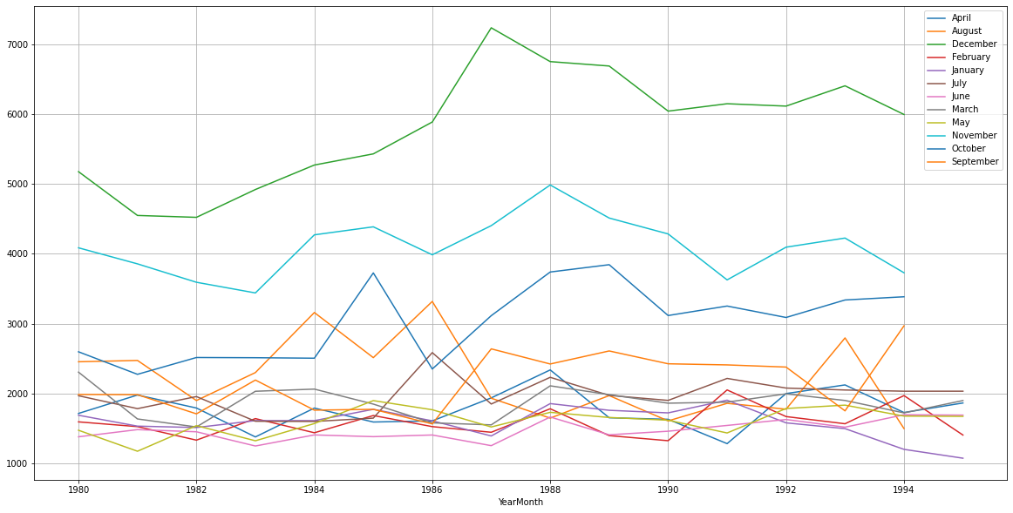
Plot 7: graph of monthly sales over the year
This plot shows that December has the highest sales over the years and the year 1988 was the year with the highest number of sales.

Correlation plot
Plot 8: correlation plot
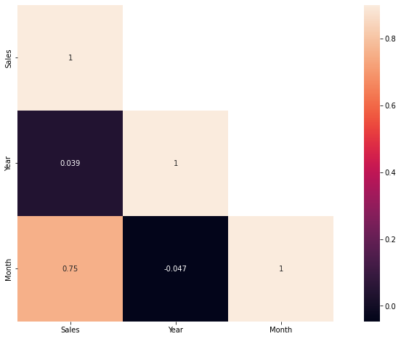
This heat map shows that there is a low correlation between sales and year. there is a more correlation between month and sales. It indicated seasonal patterns in sales

Plot ECDF: Empirical Cumulative Distribution Function
This graph shows the distribution of data.
Plot 9: ECDF plot
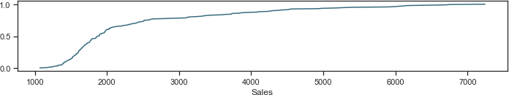

This plot shows:
  - More than 50% of sales have been less than 2000
  - Highest values is 7000
  - Approx 80% of sales have been less than 3000

Decomposition -Additive
Plot 10: decomposition plot addictive
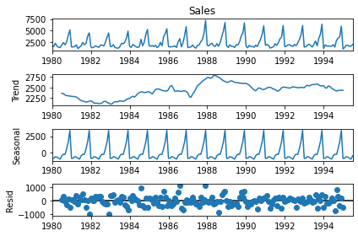
The plots show:
  - Peak year 1988-1989

  - It also shows that the trend has declined over the year after 1988-1989.
  - Residue is spread and is not in a straight line.
  - Both trend and seasonality are present.

Decomposition-Multiplicative
Plot 11: decomposition plot - mulatiplicative
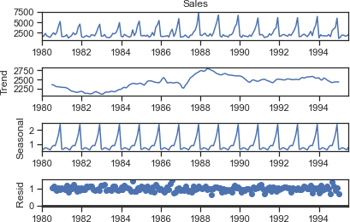

The plots show
  - Peak year 1988-1989
  - It also shows that the trend has declined over the year after 1988-1989.
  - Residue is spread and is in approx a straight line.
  - Both trend and seasonality are present.
  - Reside is 0 to 1, while additive is 0 to 1000.
  - So multiplicative model is selected owing to a more stable residual plot and lower range of residual

Split the data into training and test. The test data should start in 1991.

plot 12: line plot train and test dataset
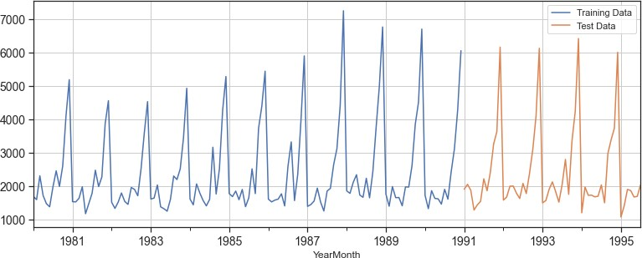

As per the instructions given in the project we have split the data, around 1991. With training data from 1980 to 1990 December. Test data starts from the ﬁrst month of January 1991 till the end.
Rows and Columns:
train dataset has 132 rows and 3 columns. test dataset has 55 and 3 columns.

Few Rows of datasets:
Table 5: train and test dataset
Train dataset | Test dataset
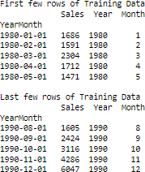 | 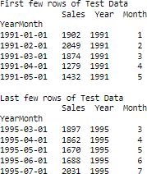

Build all the exponential smoothing models on the training data and evaluate the model using RMSE on the test data. Other models such as regression,naïve forecast models, and simple average models. should also be built on the training data and check the performance on the test data using RMSE.

  - Model 1:Linear Regression
  - Model 2: Naive Approach
  - Model 3: Simple Average
  - Model 4: Moving Average(MA)
  - Model 5: Simple Exponential Smoothing
  - Model 6: Double Exponential Smoothing (Holt's Model)
  - Model 7: Triple Exponential Smoothing (Holt - Winter's Model)

Model 1: Linear Regression
Plot 13: linear regression
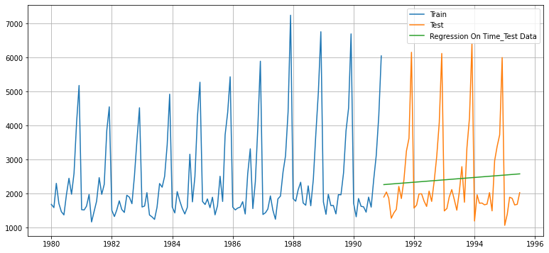

The green line indicates the predictions made by the model, while the orange values are the actual test values. It is clear the predicted values are very far off from the actual values

Model was evaluated using the RMSE metric. Below is the RMSE calculated for this model.

Linear Regression 1275.867052

Model 2: Naive Approach:

Plot 14: naive approve

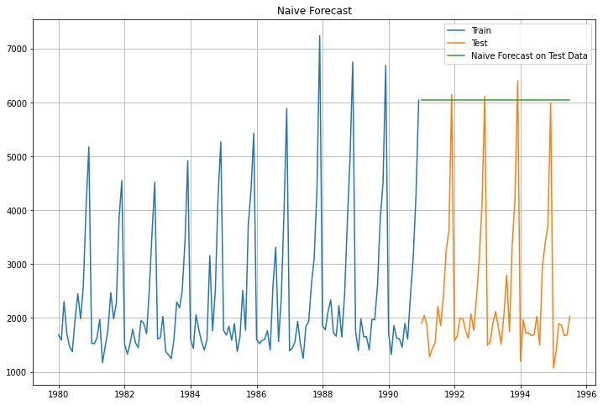

The green line indicates the predictions made by the model, while the orange values are the actual test values. It is clear the predicted values are very far off from the actual values

Model was evaluated using the RMSE metric. Below is the RMSE calculated for this model.

Naive Model 3864.279352

Model 3: Simple Average

Plot 15: simple average

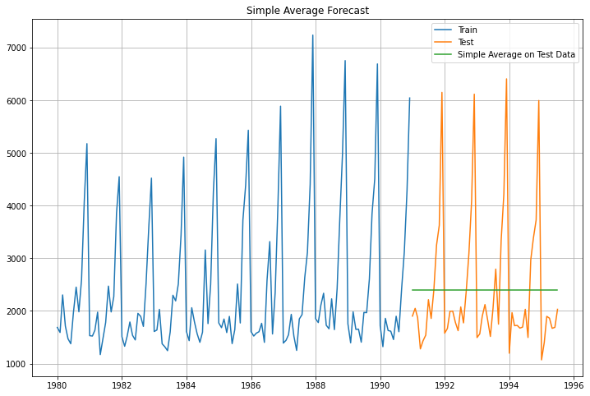

The green line indicates the predictions made by the model, while the orange values are the actual test values. It is clear the predicted values are very far off from the actual values

Model was evaluated using the RMSE metric. Below is the RMSE calculated for this model.

Simple Average Model 1275.081804

Model 4: Moving Average
Plot 16: moving average

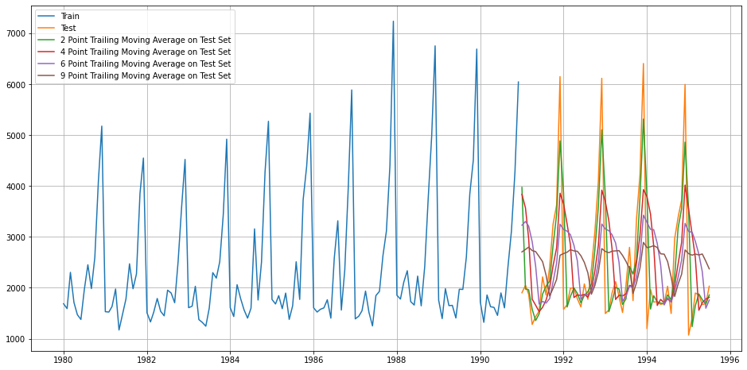

Model was evaluated using the RMSE metric. Below is the RMSE calculated for this model.

2pointTrailingMovingAverage | 813.400684
4pointTrailingMovingAverage | 1156.589694
6pointTrailingMovingAverage | 1283.927428
9pointTrailingMovingAverage | 1346.278315

We have made multiple moving average models with rolling windows varying from 2 to 9. Rolling average is a better method than simple average as it takes into account only the previous n values to make the prediction, where n is the rolling window deﬁned. This takes into account the recent trends and is in general more accurate. The higher the rolling window, the smoother will be its curve, since more values are being taken into account.

Model 5: Simple Exponential Smoothing
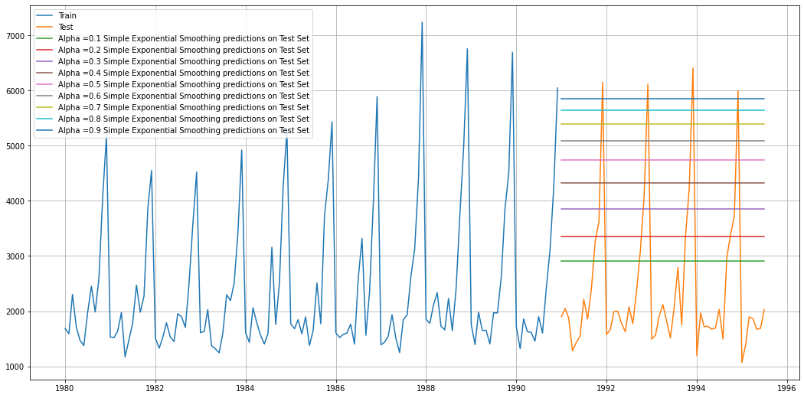
Plot 17: simple exponential smothing
Model was evaluated using the RMSE metric. Below is the RMSE calculated for this model.

 |  | Alpha Values |  |  | Test RMSE
 | 0.1 |  |  | 1375.393398
 | 0.2 |  |  | 1595.206839
 | 0.3 |  |  | 1935.507132
 | 0.4 |  |  | 2311.919615
 | 0.5 |  |  | 2666.351413
 | 0.6 |  |  | 2979.204388
 | 0.7 |  |  | 3249.944092
 | 0.8 |  |  | 3483.801006

Model 6: Double Exponential Smoothing (Holt's Model)
Plot 18: double exponential smoothing
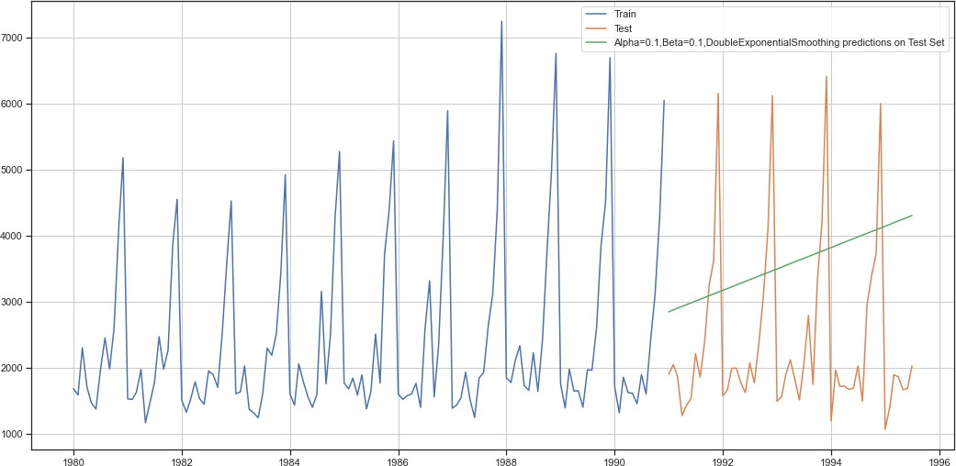

The green line indicates the predictions made by the model, while the orange values are the actual test values. It is clear the predicted values are very far off from the actual values

Model was evaluated using the RMSE metric. Below is the RMSE calculated for this model.

Alpha Value = 0.1, beta value = 0.1, DoubleExponentialSmoothing = 1778.564670

Model 7: Triple Exponential Smoothing (Holt - Winter's Model)
Plot 19: triple exponential smoothing

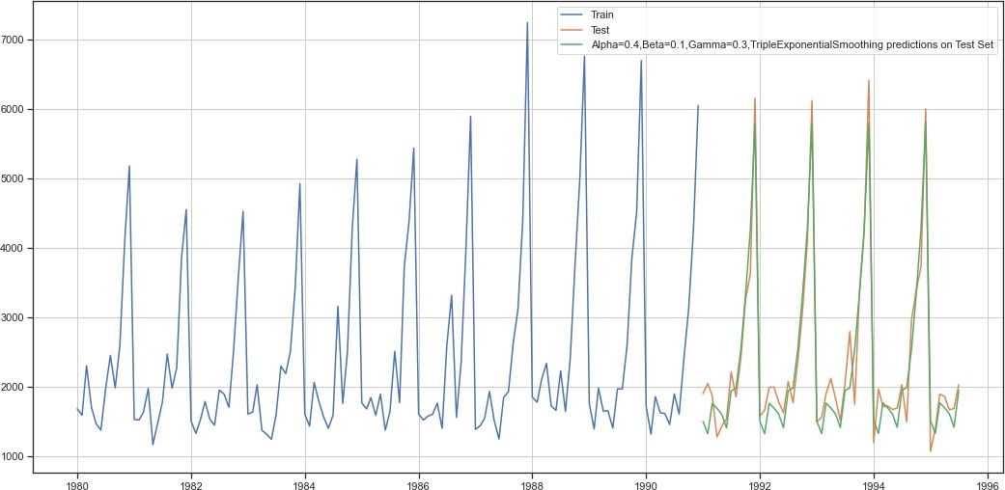

Output for a best alpha, beta, and gamma values are shown by the green color line in the above plot. The best model had both a multiplicative trends, as well as a seasonality Model, which was evaluated using the RMSE metric. Below is the RMSE calculated for this model.
Alpha=0.4,Beta=0.1,Gamma=0.3,TripleExponentialSmoothing 317.434302

- Check for the stationarity of the data on which the model is being built on using appropriate statistical tests and also mention the hypothesis for the statistical test. If the data is found to be non-stationary, take appropriate steps to make it stationary. Check the new data for stationarity and comment. Note: Stationarity should be checked at alpha = 0.05.
Check for stationarity of the whole Time Series data.
The Augmented Dickey-Fuller test is an unit root test which determines whether there is a unit root and subsequently whether the series is non-stationary.

The hypothesis in a simple form for the ADF test is:

  - H0 : The Time Series has a unit root and is thus non-stationary.
  - H1 : The Time Series does not have a unit root and is thus stationary.

We would want the series to be stationary for building ARIMA models and thus we would want the p-value of this test to be less than the α value.

We see that at 5% significant level the Time Series is non-stationary.

Plot 20: plot for dickey fuller test

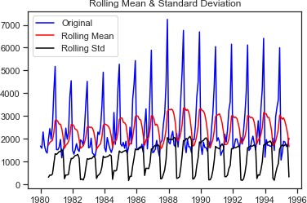

Results of Dickey-Fuller Test:
p-value 0.601061

In order to try and make the series stationary we used the diﬀerencing approach. We used
.diﬀ() function on the existing series without any argument, implying the default diﬀ value of 1 and also dropped the NaN values, since diﬀerencing of order 1 would generate the ﬁrst value as NaN which need to be dropped
Plot 21: plot for dickey fuller test after differencing approch
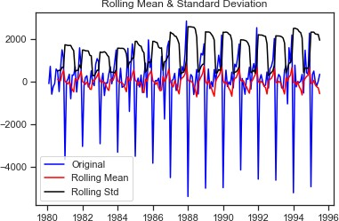

Results of Dickey-Fuller Test:
p-value 0.000000

Dickey - Fuller test was 0.000, which is obviously less than 0.05. Hence the null hypothesis that the series is not stationary at diﬀerence = 1 was rejected, which implied that the series has indeed become stationary after we performed the diﬀerencing. Null hypothesis was rejected since the p-value was less than alpha i.e. 0.05. Also the rolling mean plot was a straight line this time around. Also the series looked more or less the same from both the directions, indicating stationarity.

We could now proceed ahead with ARIMA/ SARIMA models, since we had made the series stationary.

- .Build an automated version of the ARIMA/SARIMA model in which the parameters are selected using the lowest Akaike Information Criteria (AIC) on the training data and evaluate this model on the test data using RMSE.
AUTO - ARIMA model
We employed a for loop for determining the optimum values of p,d,q, where p is the order of the AR (Auto-Regressive) part of the model, while q is the order of the MA (Moving Average) part of the model. d is the differencing that is required to make the series stationary. p,q values in the range of (0,4) were given to the for loop, while a ﬁxed value of 1 was given for d, since we had already determined d to be 1, while checking for stationarity using the ADF test.
Some parameter combinations for the Model... Model: (0, 1, 1)
Model: (0, 1, 2)
Model: (0, 1, 3)
Model: (1, 1, 0)
Model: (1, 1, 1)
Model: (1, 1, 2)
Model: (1, 1, 3)
Model: (2, 1, 0)
Model: (2, 1, 1)
Model: (2, 1, 2)
Model: (2, 1, 3)
Model: (3, 1, 0)
Model: (3, 1, 1)
Model: (3, 1, 2)
Model: (3, 1, 3)
Akaike information criterion (AIC) value was evaluated for each of these models and the model with least AIC value was selected.

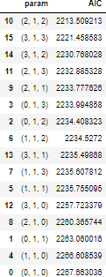

the summary report for the ARIMA model with values (p=2,d=1,q=2).
SARIMAX Results
==============================================================================
Dep. Variable: Sales No. Observations: 132
Model: ARIMA(2, 1, 2) Log Likelihood -1101.755
Date: Sat, 08 Jul 2023 AIC 2213.509
Time: 08:22:24 BIC 2227.885
Sample: 01-01-1980 HQIC 2219.351
- 12-01-1990
Covariance Type: opg
==============================================================================
coef std err z P>|z| [0.025 0.975]
------------------------------------------------------------------------------
ar.L1 1.3121 0.046 28.782 0.000 1.223 1.401
ar.L2 -0.5593 0.072 -7.740 0.000 -0.701 -0.418
ma.L1 -1.9917 0.109 -18.216 0.000 -2.206 -1.777
ma.L2 0.9999 0.110 9.108 0.000 0.785 1.215
sigma2 1.099e+06 1.99e-07 5.51e+12 0.000 1.1e+06 1.1e+06
===================================================================================
Ljung-Box (L1) (Q): 0.19 Jarque-Bera (JB): 14.46
Prob(Q): 0.67 Prob(JB): 0.00
Heteroskedasticity (H): 2.43 Skew: 0.61
Prob(H) (two-sided): 0.00 Kurtosis: 4.08
===================================================================================

Warnings:
[1] Covariance matrix calculated using the outer product of gradients (complex-step).
[2] Covariance matrix is singular or near-singular, with condition number 3.65e+28. Standard errors may be unstable.

RMSE values are as below:

Auto_ARIMA 1299.978401

AUTO- SARIMA Model
A similar for loop like AUTO_ARIMA with below values was employed, resulting in the models shown below.
p = q = range(0, 4) d= range(0,2) D = range(0,2) pdq = list(itertools.product(p, d, q)) model_pdq = [(x[0], x[1], x[2], 12) for x in list(itertools.product(p, D, q))]
Examples of some parameter combinations for Model... Model: (0, 1, 1)(0, 0, 1, 12)
Model: (0, 1, 2)(0, 0, 2, 12)
Model: (0, 1, 3)(0, 0, 3, 12)
Model: (1, 1, 0)(1, 0, 0, 12)
Model: (1, 1, 1)(1, 0, 1, 12)
Model: (1, 1, 2)(1, 0, 2, 12)
Model: (1, 1, 3)(1, 0, 3, 12)
Model: (2, 1, 0)(2, 0, 0, 12)
Model: (2, 1, 1)(2, 0, 1, 12)
Model: (2, 1, 2)(2, 0, 2, 12)
Model: (2, 1, 3)(2, 0, 3, 12)
Model: (3, 1, 0)(3, 0, 0, 12)
Model: (3, 1, 1)(3, 0, 1, 12)
Model: (3, 1, 2)(3, 0, 2, 12)
Model: (3, 1, 3)(3, 0, 3, 12)

Akaike information criterion (AIC) value was evaluated for each of these models and the model with least AIC value was selected. Here only the top 5 models are shown.
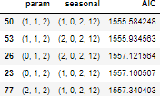
the summary report for the best SARIMA model with values (2,1,2)(2,0,2,12)

SARIMAX Results
==========================================================================================
Dep. Variable: y No. Observations: 132
Model: SARIMAX(1, 1, 2)x(1, 0, 2, 12) Log Likelihood -770.792
Date: Sat, 08 Jul 2023 AIC 1555.584
Time: 08:47:07 BIC 1574.095
Sample: 0 HQIC 1563.083
- 132
Covariance Type: opg
==============================================================================
coef std err z P>|z| [0.025 0.975]
------------------------------------------------------------------------------
ar.L1 -0.6281 0.255 -2.463 0.014 -1.128 -0.128
ma.L1 -0.1041 0.225 -0.463 0.643 -0.545 0.337
ma.L2 -0.7276 0.154 -4.734 0.000 -1.029 -0.426
ar.S.L12 1.0439 0.014 72.842 0.000 1.016 1.072
ma.S.L12 -0.5551 0.098 -5.663 0.000 -0.747 -0.363
ma.S.L24 -0.1355 0.120 -1.133 0.257 -0.370 0.099
sigma2 1.506e+05 2.03e+04 7.400 0.000 1.11e+05 1.9e+05
===================================================================================
Ljung-Box (L1) (Q): 0.04 Jarque-Bera (JB): 11.72
Prob(Q): 0.84 Prob(JB): 0.00
Heteroskedasticity (H): 1.47 Skew: 0.36
Prob(H) (two-sided): 0.26 Kurtosis: 4.48
===================================================================================

Warnings:
[1] Covariance matrix calculated using the outer product of gradients (complex-step).

We also plotted the graphs for the residual to determine if any further information can be extracted or all the usable information has already been extracted. Below were the plots for the best auto SARIMA model.
Plot 22: SARIMA plot
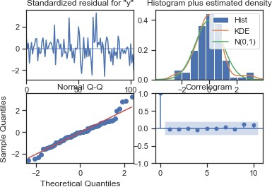

RSME of Model:

528.6069474180102
Manual- ARIMA Model
PFB the ACF plot on data
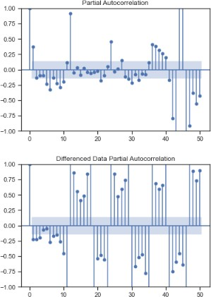

training data with diﬀ(1):
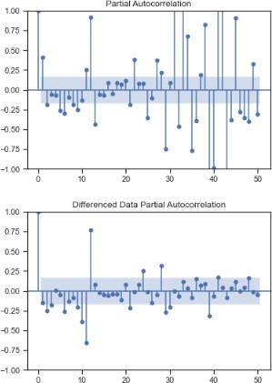

Looking at ACF plot we can see a shard decay after lag 1 for original as well as diﬀerenced data.hence we select the q value to be 1. i.e. q=1.
Looking at PACF plot we can again see signiﬁcant bars till lag 1 for diﬀerenced series which is stationary in nature, post 1 the decay is large enough. Hence we choose p value to be 1.
i.e. p=1. d values will be 1, since we had seen earlier that the series is stationary with lag1.

SARIMAX Results
==============================================================================
Dep. Variable: Sales No. Observations: 132
Model: ARIMA(1, 1, 1) Log Likelihood -1114.878
Date: Sat, 08 Jul 2023 AIC 2235.755
Time: 08:50:58 BIC 2244.381
Sample: 01-01-1980 HQIC 2239.260
- 12-01-1990
Covariance Type: opg
==============================================================================
coef std err z P>|z| [0.025 0.975]
------------------------------------------------------------------------------
ar.L1 0.4494 0.043 10.366 0.000 0.364 0.534
ma.L1 -0.9996 0.102 -9.811 0.000 -1.199 -0.800
sigma2 1.401e+06 7.57e-08 1.85e+13 0.000 1.4e+06 1.4e+06
===================================================================================
Ljung-Box (L1) (Q): 0.50 Jarque-Bera (JB): 10.42
Prob(Q): 0.48 Prob(JB): 0.01
Heteroskedasticity (H): 2.64 Skew: 0.46
Prob(H) (two-sided): 0.00 Kurtosis: 4.03
===================================================================================

Warnings:
[1] Covariance matrix calculated using the outer product of gradients (complex-step).
[2] Covariance matrix is singular or near-singular, with condition number 2.92e+27. Standard errors may be unstable.

Hence the values selected for manual ARIMA:- p=1, d=1, q=1 summary from this manual ARIMA model.
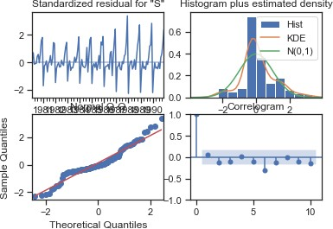
Model Evaluation: RSME

1319.9367298218867

Manual SARIMA Model
SARIMAX(1, 1, 1)x(1, 1, 1, 12)
Below is the summary of the manual SARIMA model

SARIMAX Results
==========================================================================================
Dep. Variable: y No. Observations: 132
Model: SARIMAX(1, 1, 1)x(1, 1, 1, 12) Log Likelihood -882.088
Date: Sat, 08 Jul 2023 AIC 1774.175
Time: 08:56:47 BIC 1788.071
Sample: 0 HQIC 1779.818
- 132
Covariance Type: opg
==============================================================================
coef std err z P>|z| [0.025 0.975]
------------------------------------------------------------------------------
ar.L1 0.1957 0.104 1.878 0.060 -0.009 0.400
ma.L1 -0.9404 0.053 -17.897 0.000 -1.043 -0.837
ar.S.L12 0.0711 0.242 0.294 0.769 -0.404 0.546
ma.S.L12 -0.5035 0.221 -2.277 0.023 -0.937 -0.070
sigma2 1.51e+05 1.33e+04 11.371 0.000 1.25e+05 1.77e+05
===================================================================================
Ljung-Box (L1) (Q): 0.01 Jarque-Bera (JB): 45.66
Prob(Q): 0.93 Prob(JB): 0.00
Heteroskedasticity (H): 2.61 Skew: 0.82
Prob(H) (two-sided): 0.00 Kurtosis: 5.56
===================================================================================

Warnings:
[1] Covariance matrix calculated using the outer product of gradients (complex-step).

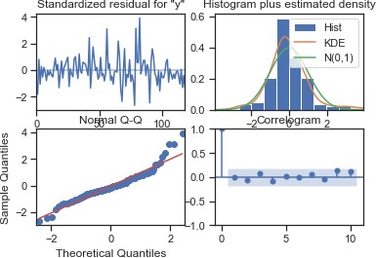

Model Evaluation: RSME

359.612454

7. Build a table (create a data frame) with all the models built along with their corresponding parameters and the respective RMSE values on the test data.

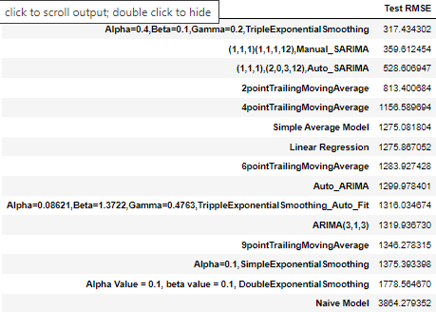

8. Based on the model-building exercise, build the most optimum model(s) on the complete data and predict 12 months into the future with appropriate confidence intervals/bands.

Based on the above comparison of all the various models that we had built, we can conclude that the triple exponential smoothing or the Holts-Winter model is giving us the lowest RMSE, hence it would be the most optimum model
sales predictions made by this best optimum model.
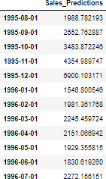

the sales prediction on the graph along with the conﬁdence intervals. PFB the graph.
Plot 27: prediction plot
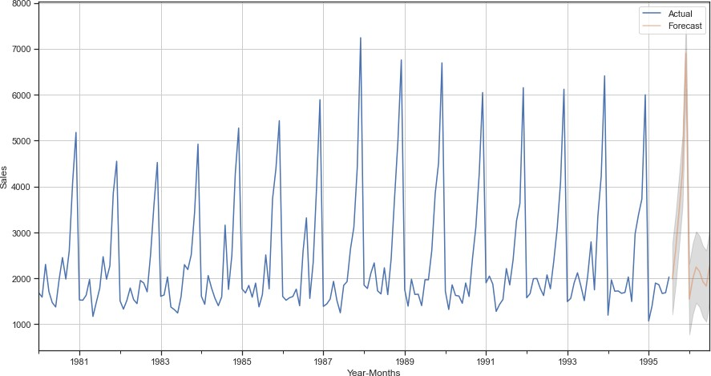

Predictions, 1 year into the future are shown in orange color, while the conﬁdence interval has been shown in grey color.

9.Comment on the model thus built and report your ﬁndings and suggest the measures that the company should be taking for future sales.

Sales Analysis and Recommendations for Sparkling Wine
- Sales Projection: The sales of Sparkling wine for the company are predicted to be at least the same as last year, if not higher. There is a potential for peak sales next year to surpass the current year's figures.

- Consistent Popularity: Sparkling wine has maintained its popularity among customers over the years, with only a marginal decline in sales. Despite reaching its peak in the late 1980s, it remains a sought-after wine choice for consumers.

- Seasonality Impact: Seasonality significantly influences the sales of Sparkling wine. Sales tend to be slower in the first half of the year, picking up from August to December.

- Marketing Campaign Opportunities: It is recommended for the company to focus on running marketing campaigns during the first half of the year when sales are typically slower, especially in the months of March to July.

- Promotional Pairings: The company could consider pairing Sparkling wine with a less popular wine, such as "Rose wine," under a special offer. This strategy aims to encourage customers to try the underperforming wine and potentially boost its sales. It provides an opportunity for cross-promotion and benefits the company by diversifying its product offerings.
By implementing these recommendations, the company can leverage the consistent popularity of Sparkling wine, optimize sales during the peak season, and strategically target the slower sales periods. The proposed promotional pairings can create additional sales opportunities and broaden customer preferences.
These measures align with the observed sales trends and provide a roadmap for the company to drive sales growth and maximize the potential of Sparkling wine in the market.

Project On Time Series
Forecasting

Rose Wine

Yogesh Negi

Problem Statement:

For this particular assignment, the data of different types of wine sales in the 20th century is to be analysed. Both of these data are from the same company but of different wines. As an analyst in the ABC Estate Wines, you are tasked to analyse and forecast Wine Sales in the 20th century.

Read the data as an appropriate Time Series data and plot the data.

Data Dictionary:
Table 1: data dictionary
column | details
YearMonth | Dates of sales
Sparkling | Sales of rose wine

Data set is read using the pandas library.
Rows of data set;
Table 2: rows of dataset
Top Few Rows : | Last Few Rows :
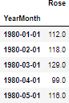 | 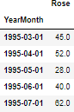

Number of Rows and Columns of Dataset:
The dataset has 187 rows and 1 column.

Plot of the dataset:
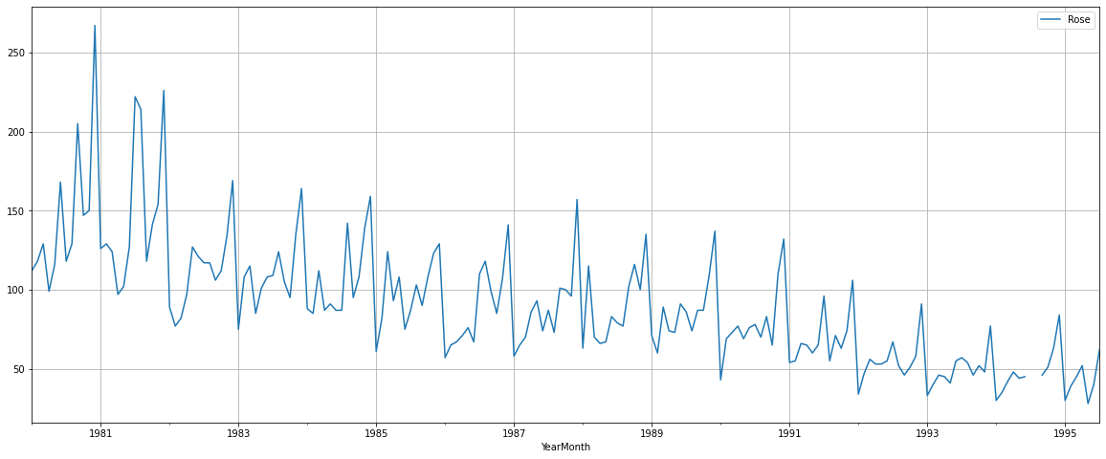
Plot 1 : dataset

Post Ingestion of Dataset:
We have divided the dataset further by extraction month and year columns from the YearMonth column and renamed the sparkling column name to Sales for better analysis od the dataset.

Rows of new data set;
Table 3: new rows of dataset
Top Few Rows : | Last Few Rows :
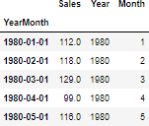 | 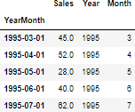

Number of Rows and Columns of Dataset: The dataset has 187 rows and 3 column.

- Perform appropriate Exploratory Data Analysis to understand the data and also perform decomposition.
Data Type;
Index: DateTime Sales: integer Month: integer Year: integer

Statistical summary:
Table 4: statistical summary

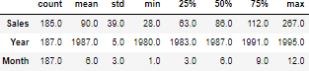

Null Value:
There are 2 null values present in sales the dataset.
We found the values for the months of July & August were missing for the year 1994.

Sales  YearMonth | Year |  | Month
1994-07-01 NaN | 1994 | 7
1994-08-01 NaN | 1994 | 8

We tried following approaches to impute the data, these were as below.

Mean - Before & After
Treating null values is very important to do further analysis.

In this approach, instead of taking means for the 7th months across all the years, we just took mean of the 7th months values from a year before and a year after the missing value.
Similar steps were taken for 8th month.

Boxplot of dataset:
Plot 2: boxplot of data
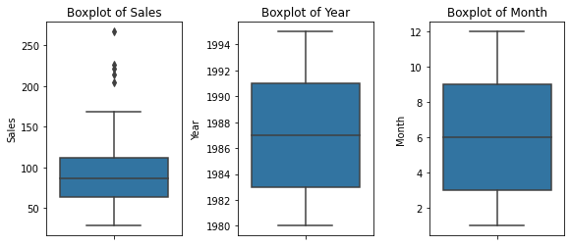
The box plot shows:
  - Sales boxplot has outliers we can treat them but we are choosing not to treat them as they do not give much eﬀect on the time series model.

Line plot of sales:
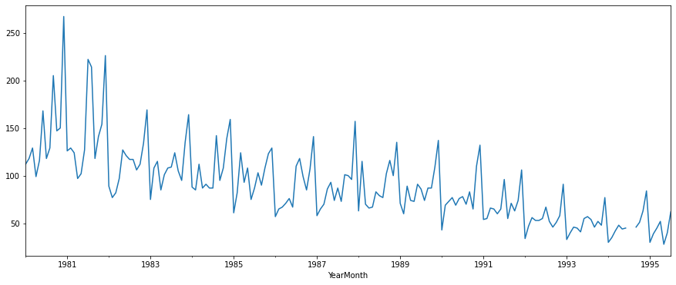
Plot 3: line plot of sales
The line plot shows the patterns of trend and seasonality and also shows that there was a peak in the year 1981.

Boxplot Yearly:
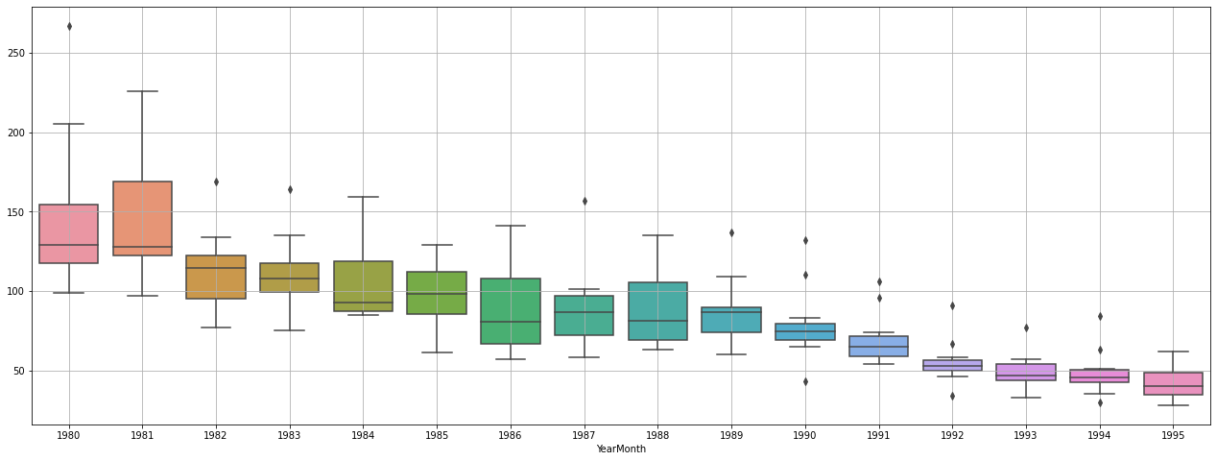
Plot 4: boxplot yearly
This yearly box plot shows there is consistency over the years and there was a peak in 1980-1981. Outliers are present in almost all years.

Boxplot Monthly:
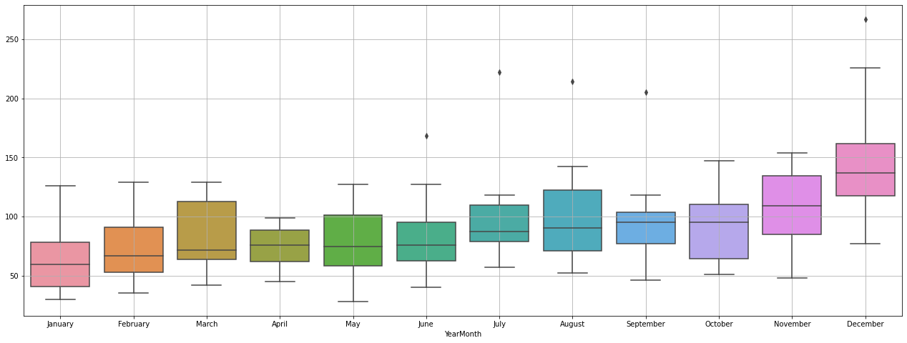
Plot 5: boxplot monthly
The plot shows that sales are highest in the month of December and lowest in the month of January. Sales are consistent from January to July then from august the sales start to increase. Outliers are present in June, July, august, September and December.

Boxplot Weekday vise:
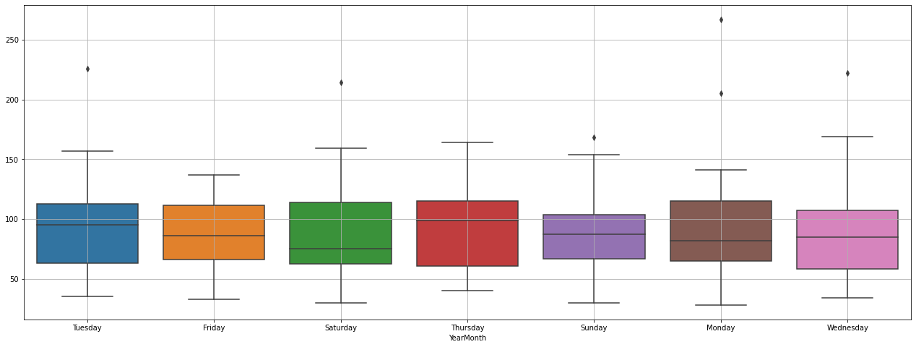
Plot 6: boxplot weekday vise
Tuesday has more sales than other days and Wednesday has the lowest sales of the week. Outliers are present on all days except Friday and Thursday.

Graph of Monthly Sales over the years:
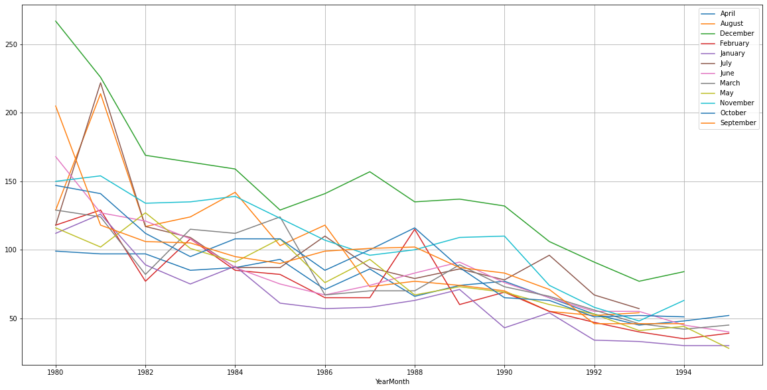
Plot 7: graph of monthly sales over the years
This plot shows that December has the highest sales over the years and the year 1981 was the year with the highest number of sales.

Correlation plot
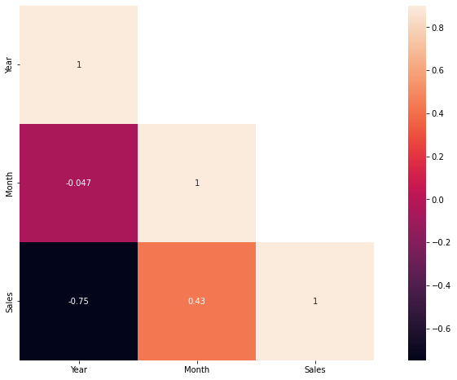
Plot 8:correlatation plot

This heat map shows that there was little correlation between Sales and the Years data, there signiﬁcantly more correlation between the month and Sales columns. Clearly indicating a seasonal pattern in our Sales data. Certain months have higher sales, while certain months have lesser.

Plot ECDF: Empirical Cumulative Distribution Function
This graph shows the distribution of data. Plot 9: ECDF plot
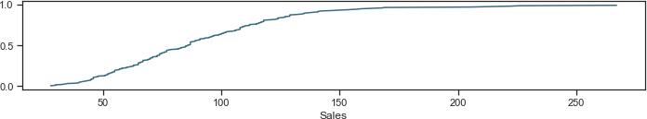

This plot shows:
  - 50% sales has been less 100
  - Highest vales is 250
  - Aprox 90% sales has been less than 150

Decomposition -Additive

Plot 10 : decomposition additive

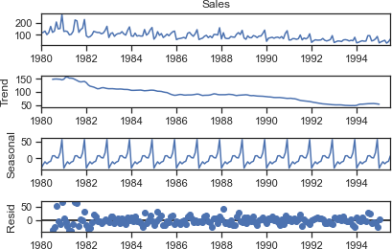

The plots show:
  - Peak year 1981
  - It also shows that the trend has declined over the year after 1981
  - Residue is spread and is not in a straight line.
  - Both trend and seasonality are present.

Decomposition-Multiplicative
Plot 11: decomposition multiplicative
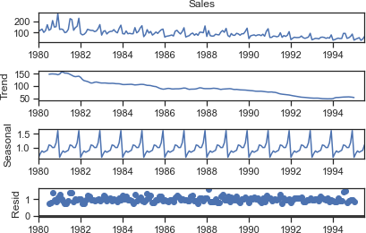

The plots show:
  - Peak year 1981
  - It also shows that the trend has declined over the year after 1981.
  - Residue is spread and is in approx a straight line.
  - Both trend and seasonality are present.
  - Reside is 0 to 1, while for additive is 0 to 50.
  - So multiplicative model is selected owing to a more stable residual plot and lower range of residuals.

Split the data into training and test. The test data should start in 1991.

Plot 12: training and test dataset
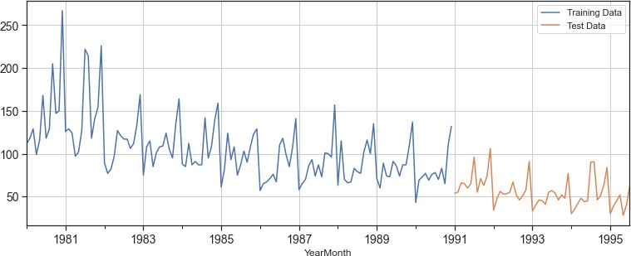
Data split from 1980-1990 is training data, then 1991 to 1995 is training data.

Rows and Columns:
train dataset has 132 rows and 3 columns. test dataset has 55 and 3 columns.

Few Rows of datasets:
Table 5: train and test dataset rows

Train dataset | Test dataset
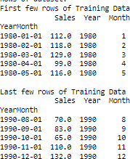 | 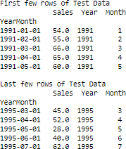

Build all the exponential smoothing models on the training data and evaluate the model using RMSE on the test data. Other models such as regression,naïve forecast models, and simple average models. should also be built on the training data and check the performance on the test data using RMSE.

  - Model 1:Linear Regression
  - Model 2: Naive Approach
  - Model 3: Simple Average
  - Model 4: Moving Average(MA)
  - Model 5: Simple Exponential Smoothing
  - Model 6: Double Exponential Smoothing (Holt's Model)
  - Model 7: Triple Exponential Smoothing (Holt - Winter's Model)

Model 1: Linear Regression

Plot 13: linear regression
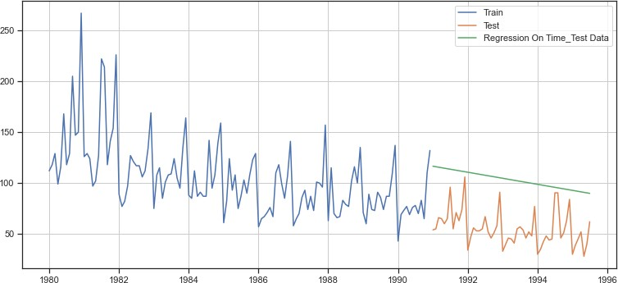

The green line indicates the predictions made by the model, while the orange values are the actual test values. It is clear the predicted values are very far off from the actual values

Model was evaluated using the RMSE metric. Below is the RMSE calculated for this model.

Linear Regression 51.080941

Model 2: Naive Approach:

Plot 14: naive approach
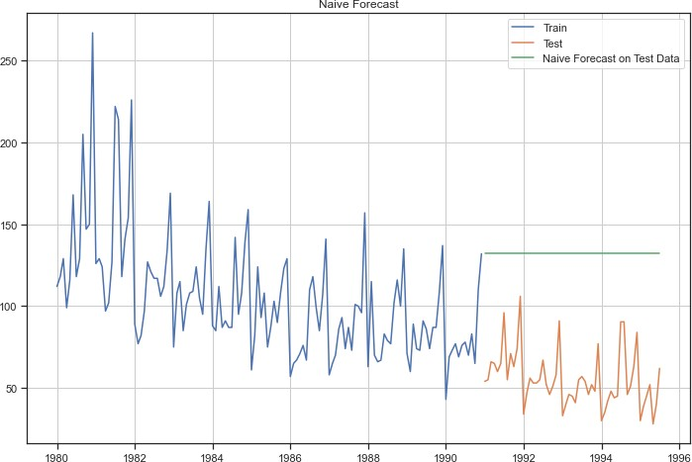

The green line indicates the predictions made by the model, while the orange values are the actual test values. It is clear the predicted values are very far off from the actual values

Model was evaluated using the RMSE metric. Below is the RMSE calculated for this model.

Naive Model 79.304391

Model 3: Simple Average

Plot 15: simple average

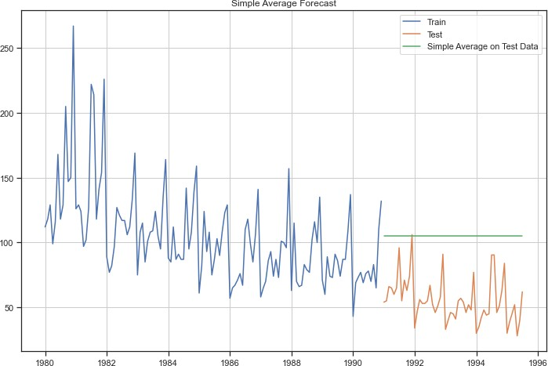

The green line indicates the predictions made by the model, while the orange values are the actual test values. It is clear the predicted values are very far off from the actual values

Model was evaluated using the RMSE metric. Below is the RMSE calculated for this model.

Simple Average Model 53.049755

Model 4: Moving Average
Plot 16: moving average
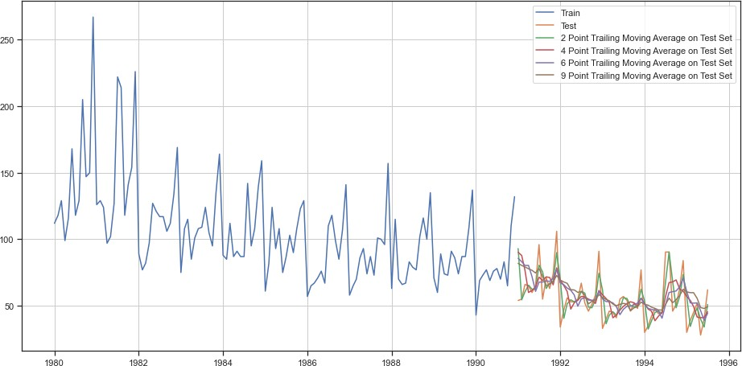

Model was evaluated using the RMSE metric. Below is the RMSE calculated for this model.

2 pointTrailingMovingAverage | 11.589082
4 pointTrailingMovingAverage | 14.506190
6 pointTrailingMovingAverage | 14.558008
9 pointTrailingMovingAverage | 14.797139

We created multiple moving average models with rolling windows varying from 2 to 9. Rolling average is a better method than simple average as it takes into account only the previous n values to make the prediction, where n is the rolling window deﬁned. This takes into account the recent trends and is in general more accurate. Higher the rolling window, smoother will be its curve, since more values are being taken into account.

Model 5: Simple Exponential Smoothing
Plot 17: simple exponential smoothing
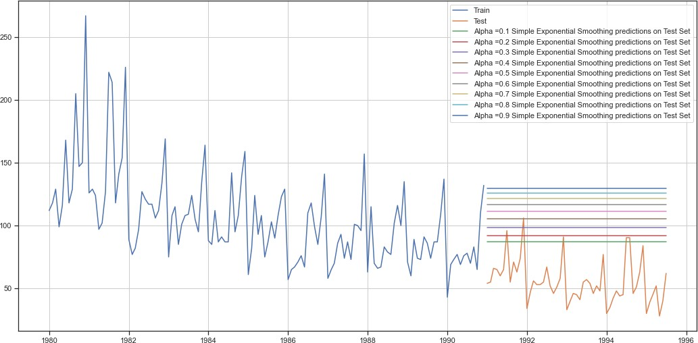
Model was evaluated using the RMSE metric. Below is the RMSE calculated for this model.

Alpha=0.1,SimpleExponentialSmoothing 36.429535

Model 6: Double Exponential Smoothing (Holt's Model)
Plot 18: double exponential smoothing
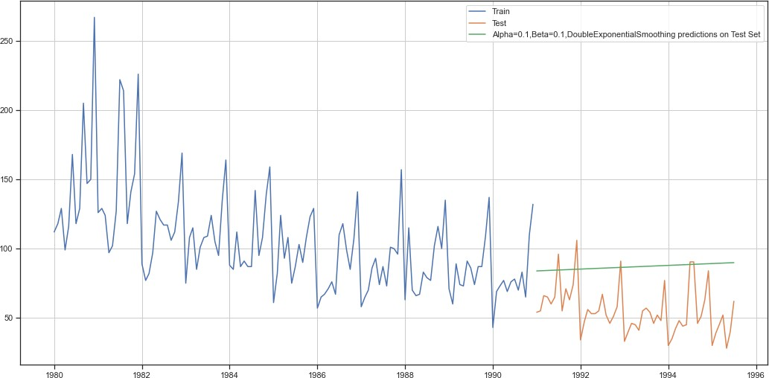
Model was evaluated using the RMSE metric. Below is the RMSE calculated for this model.

Alpha Value = 0.1, beta value = 0.1, DoubleExponentialSmoothing36.510010

Model 7: Triple Exponential Smoothing (Holt - Winter's Model)
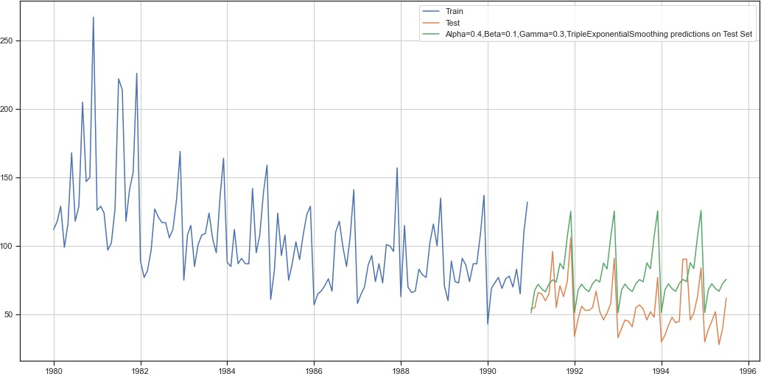
Plot19 : plot triple exponential smoothing
Output for best alpha, beta and gamma values is shown by the green color line in the above plot. Best model had both multiplicative trend as well as seasonality.

So far this is the best model

Model was evaluated using the RMSE metric. Below is the RMSE calculated for this model.

Alpha=0.4,Beta=0.1,Gamma=0.3,TripleExponentialSmoothing 8.992350

- Check for the stationarity of the data on which the model is being built on using appropriate statistical tests and also mention the hypothesis for the statistical test. If the data is found to be non-stationary, take appropriate steps to make it stationary. Check the new data for stationarity and comment. Note: Stationarity should be checked at alpha = 0.05.
Check for stationarity of the whole Time Series data.
The Augmented Dickey-Fuller test is an unit root test which determines whether there is a unit root and subsequently whether the series is non-stationary.

The hypothesis in a simple form for the ADF test is:

  - H0 : The Time Series has a unit root and is thus non-stationary.
  - H1 : The Time Series does not have a unit root and is thus stationary.

We would want the series to be stationary for building ARIMA models and thus we would want the p-value of this test to be less than the α value.

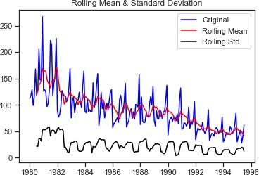
We see that at 5% significant level the Time Series is non-stationary. Plot 20: dickey fuller test

Results of Dickey-Fuller Test:

Test Statistic -1.892338
p-value 0.335674
we failed to reject the null hypothesis, which implies the Series is not stationary in nature. In order to try and make the series stationary we used the diﬀerencing approach. We used
.diﬀ() function on the existing series without any argument, implying the default diﬀ value of 1 and also dropped the NaN values, since diﬀerencing of order 1 would generate the ﬁrst value as NaN which need to be dropped

Plot 21: dickey fuller test after diﬀ
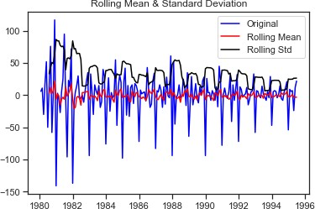
Results of Dickey-Fuller Test:
Test Statistic -8.032729e+00
p-value 1.938803e-12

the null hypothesis that the series is not stationary at diﬀerence = 1 was rejected, which implied that the series has indeed become stationary after we performed the diﬀerencing.

We could now proceed ahead with ARIMA/ SARIMA models, since we had made the series stationary.

- Build an automated version of the ARIMA/SARIMA model in which the parameters are selected using the lowest Akaike Information Criteria (AIC) on the training data and evaluate this model on the test data using RMSE.
AUTO - ARIMA model
We employed a for loop for determining the optimum values of p,d,q, where p is the order of the AR (Auto-Regressive) part of the model, while q is the order of the MA (Moving Average) part of the model. d is the differencing that is required to make the series stationary. p,q values in the range of (0,4) were given to the for loop, while a ﬁxed value of 1 was given for d, since we had already determined d to be 1, while checking for stationarity using the ADF test.
Some parameter combinations for the Model... Model: (0, 1, 1)
Model: (0, 1, 2)
Model: (0, 1, 3)
Model: (1, 1, 0)
Model: (1, 1, 1)
Model: (1, 1, 2)
Model: (1, 1, 3)
Model: (2, 1, 0)
Model: (2, 1, 1)
Model: (2, 1, 2)
Model: (2, 1, 3)
Model: (3, 1, 0)
Model: (3, 1, 1)
Model: (3, 1, 2)
Model: (3, 1, 3)
Akaike information criterion (AIC) value was evaluated for each of these models and the model with least AIC value was selected.

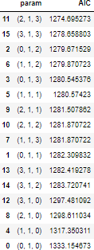

the summary report for the ARIMA model with values (p=2,d=1,q=3).
SARIMAX Results
==============================================================================
Dep. Variable: Sales No. Observations: 132
Model: ARIMA(2, 1, 3) Log Likelihood -631.348
Date: Sat, 08 Jul 2023 AIC 1274.695
Time: 09:32:32 BIC 1291.946
Sample: 01-01-1980 HQIC 1281.705
- 12-01-1990
Covariance Type: opg
==============================================================================
coef std err z P>|z| [0.025 0.975]
------------------------------------------------------------------------------
ar.L1 -1.6780 0.084 -20.018 0.000 -1.842 -1.514
ar.L2 -0.7288 0.084 -8.694 0.000 -0.893 -0.564
ma.L1 1.0448 0.649 1.609 0.108 -0.228 2.317
ma.L2 -0.7717 0.134 -5.751 0.000 -1.035 -0.509
ma.L3 -0.9045 0.589 -1.536 0.125 -2.059 0.250
sigma2 859.1032 546.561 1.572 0.116 -212.137 1930.343
===================================================================================
Ljung-Box (L1) (Q): 0.02 Jarque-Bera (JB): 24.45
Prob(Q): 0.88 Prob(JB): 0.00
Heteroskedasticity (H): 0.40 Skew: 0.71
Prob(H) (two-sided): 0.00 Kurtosis: 4.57
===================================================================================

Warnings:
[1] Covariance matrix calculated using the outer product of gradients (complex-step).

RMSE values are as below:

36.41939808200016

AUTO- SARIMA Model
A similar for loop like AUTO_ARIMA with below values was employed, resulting in the models shown below.
p = q = range(0, 4) d= range(0,2) D = range(0,2) pdq = list(itertools.product(p, d, q)) model_pdq = [(x[0], x[1], x[2], 12) for x in list(itertools.product(p, D, q))]

Examples of some parameter combinations for Model... Model: (0, 1, 1)(0, 0, 1, 12)
Model: (0, 1, 2)(0, 0, 2, 12)
Model: (0, 1, 3)(0, 0, 3, 12)
Model: (1, 1, 0)(1, 0, 0, 12)
Model: (1, 1, 1)(1, 0, 1, 12)
Model: (1, 1, 2)(1, 0, 2, 12)
Model: (1, 1, 3)(1, 0, 3, 12)
Model: (2, 1, 0)(2, 0, 0, 12)
Model: (2, 1, 1)(2, 0, 1, 12)
Model: (2, 1, 2)(2, 0, 2, 12)
Model: (2, 1, 3)(2, 0, 3, 12)
Model: (3, 1, 0)(3, 0, 0, 12)
Model: (3, 1, 1)(3, 0, 1, 12)
Model: (3, 1, 2)(3, 0, 2, 12)
Model: (3, 1, 3)(3, 0, 3, 12)

Akaike information criterion (AIC) value was evaluated for each of these models and the model with least AIC value was selected. Here only the top 5 models are shown.
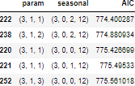
the summary report for the best SARIMA model with values (3,1,1)(3,0,2,12)

SARIMAX Results
===============================================================================================
Dep. Variable: y No. Observations: 132
Model: SARIMAX(3, 1, 1)x(3, 0, [1, 2], 12) Log Likelihood -377.200
Date: Sat, 08 Jul 2023 AIC 774.400
Time: 09:45:58 BIC 799.618
Sample: 0 HQIC 784.578
- 132
Covariance Type: opg
==============================================================================
coef std err z P>|z| [0.025 0.975]
------------------------------------------------------------------------------
ar.L1 0.0464 0.126 0.367 0.714 -0.201 0.294
ar.L2 -0.0060 0.120 -0.050 0.960 -0.241 0.229
ar.L3 -0.1808 0.098 -1.837 0.066 -0.374 0.012
ma.L1 -0.9370 0.067 -13.905 0.000 -1.069 -0.805
ar.S.L12 0.7639 0.165 4.639 0.000 0.441 1.087
ar.S.L24 0.0840 0.159 0.527 0.598 -0.229 0.397
ar.S.L36 0.0727 0.095 0.764 0.445 -0.114 0.259
ma.S.L12 -0.4968 0.250 -1.988 0.047 -0.987 -0.007
ma.S.L24 -0.2191 0.210 -1.044 0.296 -0.630 0.192
sigma2 192.1578 39.629 4.849 0.000 114.486 269.830
===================================================================================
Ljung-Box (L1) (Q): 0.30 Jarque-Bera (JB): 1.64
Prob(Q): 0.58 Prob(JB): 0.44
Heteroskedasticity (H): 1.11 Skew: 0.33
Prob(H) (two-sided): 0.77 Kurtosis: 3.03
===================================================================================

Warnings:
[1] Covariance matrix calculated using the outer product of gradients (complex-step).

We also plotted the graphs for the residual to determine if any further information can be extracted or all the usable information has already been extracted. Below were the plots for the best auto SARIMA model.
Plot 22: sarima plots
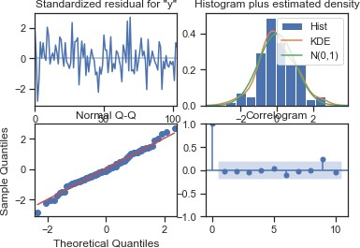

RSME of Model:

18.53550451433853
Manual- ARIMA Model
PACF the ACF plot on data :
Plot 23: PACF and ACF plots
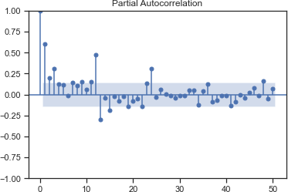

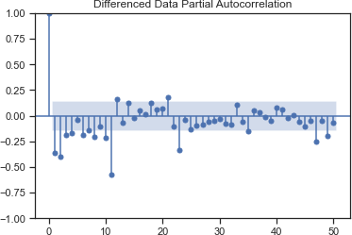

Following is plotting the PACF and ACFgraph for the training data.

Plot 24: PACF and ACF plota of train date
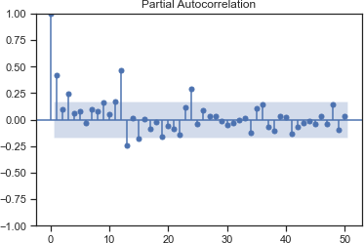

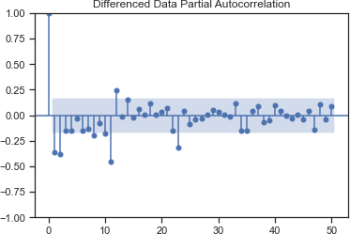

Hence the values selected for manual ARIMA:- p=2, d=1, q=2 summary from this manual ARIMA model.

SARIMAX Results
==============================================================================
Dep. Variable: Sales No. Observations: 132
Model: ARIMA(2, 1, 2) Log Likelihood -635.935
Date: Sat, 08 Jul 2023 AIC 1281.871
Time: 11:06:38 BIC 1296.247
Sample: 01-01-1980 HQIC 1287.712
- 12-01-1990
Covariance Type: opg
==============================================================================
coef std err z P>|z| [0.025 0.975]
------------------------------------------------------------------------------
ar.L1 -0.4540 0.469 -0.969 0.333 -1.372 0.464
ar.L2 0.0001 0.170 0.001 0.999 -0.334 0.334
ma.L1 -0.2541 0.459 -0.554 0.580 -1.154 0.646
ma.L2 -0.5984 0.430 -1.390 0.164 -1.442 0.245
sigma2 952.1601 91.424 10.415 0.000 772.973 1131.347
===================================================================================
Ljung-Box (L1) (Q): 0.02 Jarque-Bera (JB): 34.16
Prob(Q): 0.88 Prob(JB): 0.00
Heteroskedasticity (H): 0.37 Skew: 0.79
Prob(H) (two-sided): 0.00 Kurtosis: 4.94
===================================================================================

Warnings:
[1] Covariance matrix calculated using the outer product of gradients (complex-step).

Plot 25: manual arima model plots
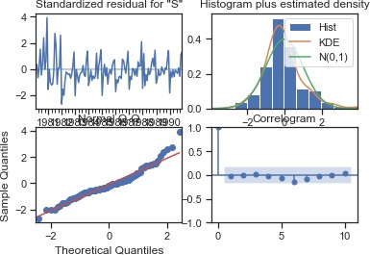

Model Evaluation: RSME
RMSE: 36.47322487814613

Manual SARIMA Model
Looking at the ACF and PACF plots for training data, we can clearly see signiﬁcant spikes at lags 12,24,36,48 etc, indicating a seasonality of 12. The parameters used for manual SARIMA model are as below.
SARIMAX(2, 1, 2)x(2, 1, 2, 12)
Below is the summary of the manual SARIMA model

SARIMAX Results
==========================================================================================
Dep. Variable: y No. Observations: 132
Model: SARIMAX(2, 1, 2)x(2, 1, 2, 12) Log Likelihood -538.016
Date: Sat, 08 Jul 2023 AIC 1094.031
Time: 11:06:49 BIC 1119.044
Sample: 0 HQIC 1104.188
- 132
Covariance Type: opg
==============================================================================
coef std err z P>|z| [0.025 0.975]
------------------------------------------------------------------------------
ar.L1 -0.5492 0.228 -2.409 0.016 -0.996 -0.102
ar.L2 -0.0744 0.099 -0.753 0.451 -0.268 0.119
ma.L1 -0.1703 0.216 -0.787 0.431 -0.594 0.254
ma.L2 -0.6694 0.228 -2.937 0.003 -1.116 -0.223
ar.S.L12 -1.0135 0.524 -1.936 0.053 -2.040 0.013
ar.S.L24 -0.1003 0.175 -0.572 0.567 -0.444 0.243
ma.S.L12 0.2908 25.246 0.012 0.991 -49.190 49.771
ma.S.L24 -0.7076 17.972 -0.039 0.969 -35.932 34.517
sigma2 430.4507 1.07e+04 0.040 0.968 -2.05e+04 2.13e+04
===================================================================================
Ljung-Box (L1) (Q): 0.02 Jarque-Bera (JB): 27.15
Prob(Q): 0.90 Prob(JB): 0.00
Heteroskedasticity (H): 0.33 Skew: 0.26
Prob(H) (two-sided): 0.00 Kurtosis: 5.28
===================================================================================

Warnings:
[1] Covariance matrix calculated using the outer product of gradients (complex-step).

Plot 26: manula sarima plots
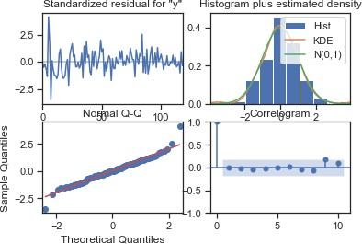

Model Evaluation: RSME

14.975746352466942

7. Build a table (create a data frame) with all the models built along with their corresponding parameters and the respective RMSE values on the test data.

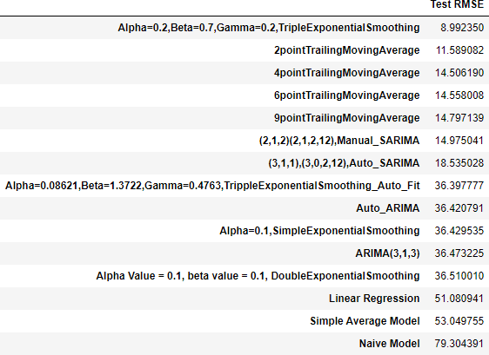

We can clearly see that triple exponential smoothing model with alpha 0.1, beta 0.7 and gamma 0.2 is the best as it he the lowest RSME score.

8 Based on the model-building exercise, build the most optimum model(s) on the complete data and predict 12 months into the future with appropriate confidence intervals/bands.

Based on the above comparison of all the various models that we had built, we can conclude that the triple exponential smoothing or the Holts-Winter model is giving us the lowest RMSE, hence it would be the most optimum model
sales predictions made by this best optimum model.
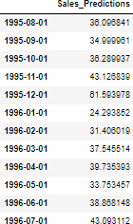

the sales prediction on the graph along with the conﬁdence intervals. PFB the graph.

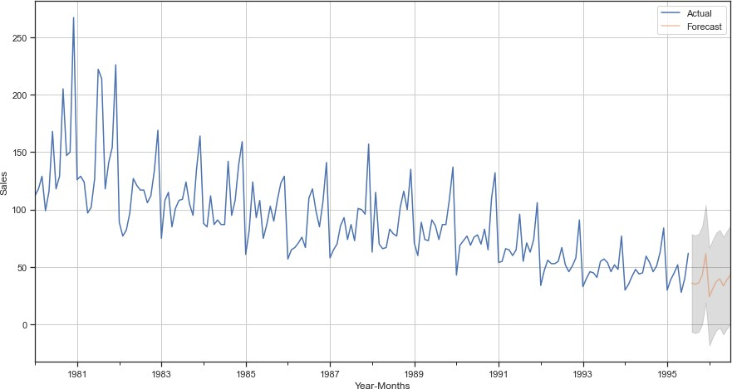
Plot 27: prediction plot
Predictions, 1 year into the future are shown in orange color, while the conﬁdence interval has been shown in grey color.

9. Comment on the model thus built and report your ﬁndings and suggest the measures that the company should be taking for future sales.
Analysis and Recommendations for Rose Wine Sales

- Declining Popularity: Analysis of the wine sales data reveals a clear downward trend for the Rose wine variety for the company. The popularity of Rose wine has been declining for over a decade.

- Future Trend Prediction: Based on the predictions of the most optimal model, this downward trend is expected to continue in the future.

- Seasonal Influence: Wine sales are significantly influenced by seasonal changes. Sales tend to increase during the festival season, while they decline during peak winter months, particularly in January.

- Campaign Opportunities: To counteract the subdued sales during the rest of the year, the company should consider running campaigns to boost the consumption of Rose wine. Specifically, campaigns during the lean period from April to June are likely to yield maximum results, as sales are typically low during this period.

- Peak Period Considerations: Running campaigns during peak periods, such as festivals, may not generate a significant impact on sales, as they are already high during this time of the year. Therefore, it is advisable to focus marketing efforts on other periods.

- Avoiding Peak Winter Campaigns: It is not recommended to run campaigns during peak winter time, especially in January, as people are less likely to purchase wine due to climatic reasons. Campaigns during this period may not effectively change people's purchasing behavior.

- Revamp Strategies: The company should also consider exploring the reasons behind the decline in the popularity of Rose wine. It may be necessary to revamp production and marketing strategies to regain market share and enhance the overall performance of the wine in the market.

By implementing these recommendations, the company can address the declining trend in Rose wine sales and optimize its marketing efforts. By focusing on the lean period and avoiding peak winter campaigns, the company can effectively boost sales and regain market share. Additionally, understanding the underlying reasons for the decline and making necessary strategic adjustments will position the company for improved performance in the future.

